**UML DIAGRAMS**

**1)**use case diagram

**a.**

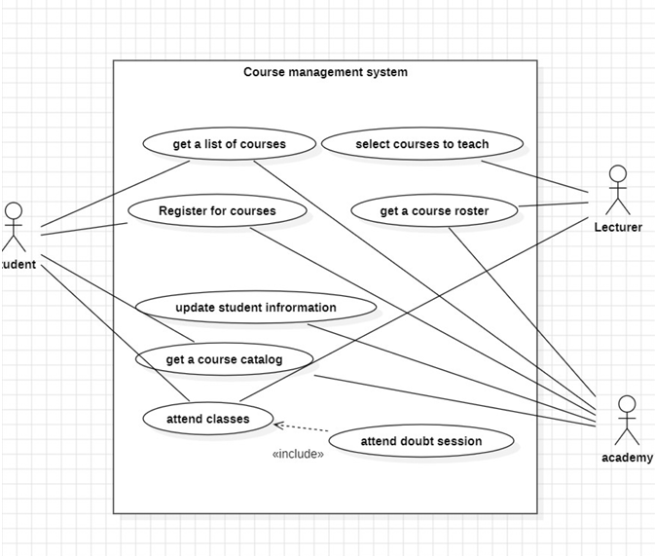

**b.**

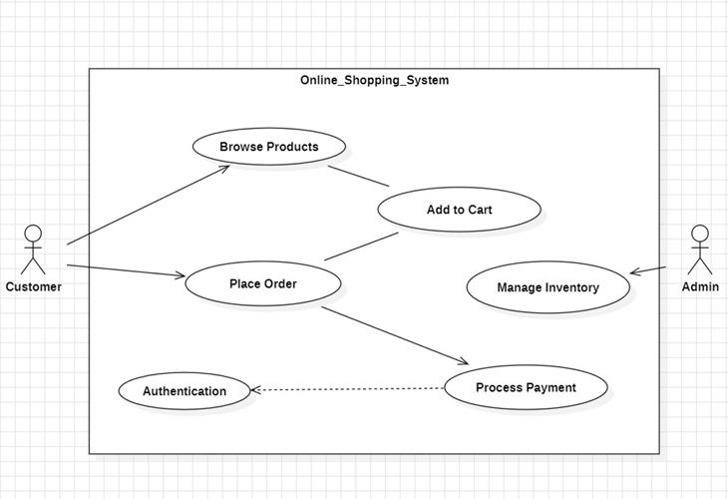

**2)class diagram**

**a.**

**b.**

**3)sequence diagram**

**a.**

**b.**

**4)commucation Diagram**

**a.**

**b.**

**5)**

**a.**

**b.**

